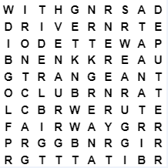
golf
putter
fairway
club
driver
tee
green
range
bunker
iron

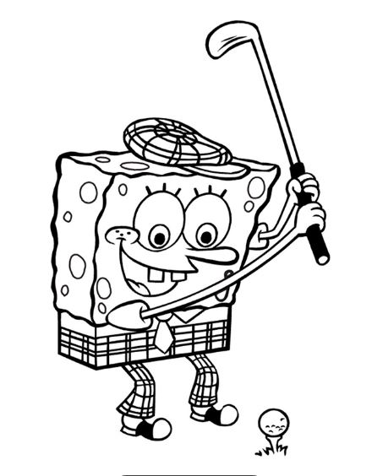

Kid’s Choices

At Elmwood, we like to encourage healthy eating, especially for our “younger customers”, that’s why we`ve put together a selection of dishes to suit different Children’s requirements and tastes.

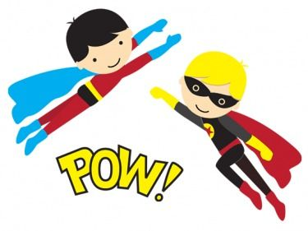

A small bowl of soup served with a slice of bread

£2.25

Main Meals

Steak pie

£4.85

Chicken nuggets

£4.75

Scampi

£4.95

Burger in a bun

£4.75

Macaroni cheese

£4.75

The above meals are served with fries or new potatoes, baked beans, fresh vegetables or salad

*

All main meals are followed by 2 scoops of ice cream with chocolate or red berry sauce

www.elmwoodgolf.co.uk

