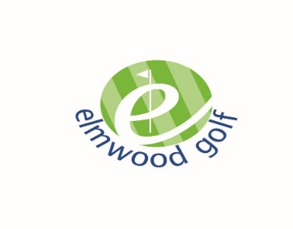
Easy Dining Menu

To Begin…

Homemade Soup of the Day
Served with crusty bread V (GF option available) £3.75

Fairways Haggis Bon Bons
With garlic & parsley mayonnaise (v option available) £4.75

Traditional Cullen Skink
Creamy chowder of smoked haddock, leeks & potato
Served with crusty bread (GF option available) £4.75

Quenelle of smooth Chicken liver parfait
with cracked pepper oatcakes, beetroot, orange & cranberry chutney £4.75
Breaded Chicken Goujons
With Cajun mayo dip GF £4.85

Fairways Favourites…

Beer Battered Fillet of North Sea Haddock
Tartare sauce, clubhouse salad, lemon & fries £8.95

Pan fried Pork Tenderloin Steak
Fife black pudding, caramelised apple & cider & wholegrain mustard cream *£9.95

Steak and Ale Pie
A casserole of beef & onions slow cooked in ale & topped with crisp butter pastry *£8.95

Traditional roasted turkey
with chipolata bacon wraps, herb & onion stuffing, roast pan gravy & cranberry relish *£9.95

The Fairways Burger
Angus burger in a brioche bun with bacon, smoked Applewood cheese, £8.95
Iceberg mayonnaise, tomato chilli relish, clubhouse salad & fries(GF option available)
Enchilada; baked in the oven & topped with mozzarella cheese, tomato chilli relish
& garlic mayo
Choose from Cajun fried Chicken, Beef Chilli or Vegetarian 5 Bean stew *£8.75

Mac ‘n’ Cheese
Macaroni made with mature cheddar cheese & served with garlic bread,
Clubhouse salad & fries V £7.95

Whole tail Breaded Scampi
Tartare sauce, clubhouse salad, lemon & fries £8.85

(* Denotes - served with new potatoes & vegetables, fries or a mixed leaf salad)

Sides…
Bowl of Fries £2.30
Cajun fries £2.30
Beer battered onion rings £2.40
Potato Wedges £2.30
Clubhouse mixed salad £2.10
Garlic bread £3.00
Garlic bread & cheese £3.25

Salads & Light Bites…

Baked Jacket Potato & Clubhouse Salad £5.65
Choose from:

- Tuna & spring onion mayo
- Mature Scottish cheddar & caramelised onion chutney
- Honey roast Ayrshire ham & coleslaw
- Egg & cress mayo
- Baked beans n cheese
- Prawns Marie Rose

Soup or Chowder & Sandwich Combo
A freshly prepared sandwich on white or whole-meal bread, clubhouse salad & coleslaw

Soup Combo £6.45
Cullen Skink Combo £6.75
Choose from:
- Tuna & spring onion mayo
- Mature Scottish cheddar & caramelised onion chutney
- Honey roast Ayrshire ham
- Egg & cress mayo
- Prawns Marie Rose

Food Allergies & Intolerances:
Please make us aware of any special dietary requirements or allergies & we will do our utmost to accommodate you.
Many of our dishes can be adapted to be gluten free. Please ask your server for a more detailed list.
Although most of our dishes are prepared on the premises, we cannot guarantee that they are free from traces of nuts etc.
Prices are inclusive of VAT @ 20%

www.elmwoodgolf.co.uk

Follow us on Facebook, Twitter & Instagram

